FUNDAMENTALS OF DATA SCIENCE (FODS) - ALL 40 LAB EXERCISES (EX-1 TO EX-40)
EX-1: Student Subject Averages using NumPy
import numpy as np
student_scores = np.array([
[80, 75, 85, 70],
[90, 85, 80, 75],
[70, 80, 90, 85],
[85, 90, 95, 80]
])
subjects = ["Math", "Science", "English", "History"]
average = np.mean(student_scores, axis=0)
for i in range(4):
print(subjects[i], "Average =", average[i])
highest = np.argmax(average)
print("Highest average subject:", subjects[highest])
OUTPUT:
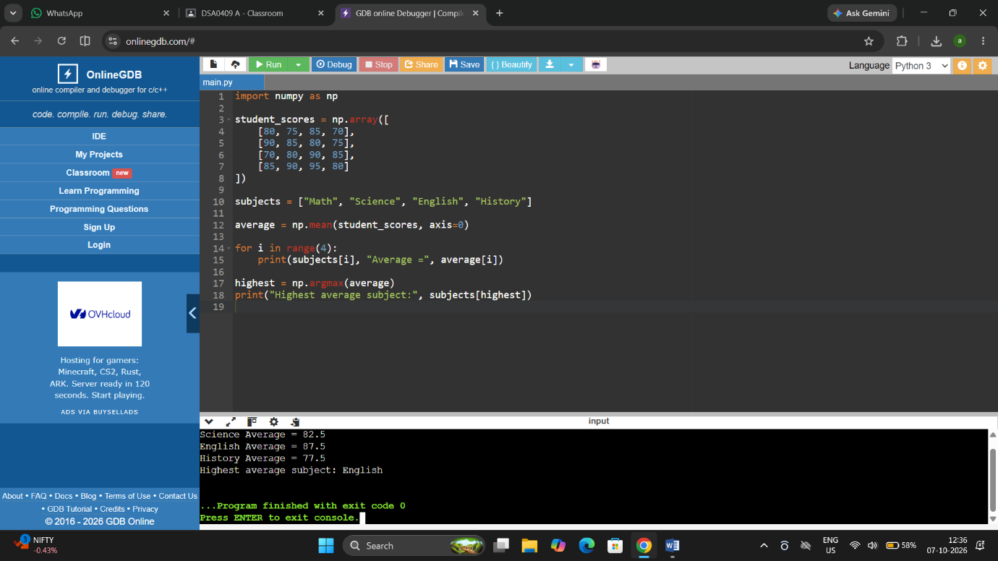

EX-2: Average Product Price using NumPy
import numpy as np
prices = np.array([
[100, 120, 150],
[80, 90, 110],
[200, 180, 160]
])
average_price = np.mean(prices)
print("Average price =", average_price)
OUTPUT:

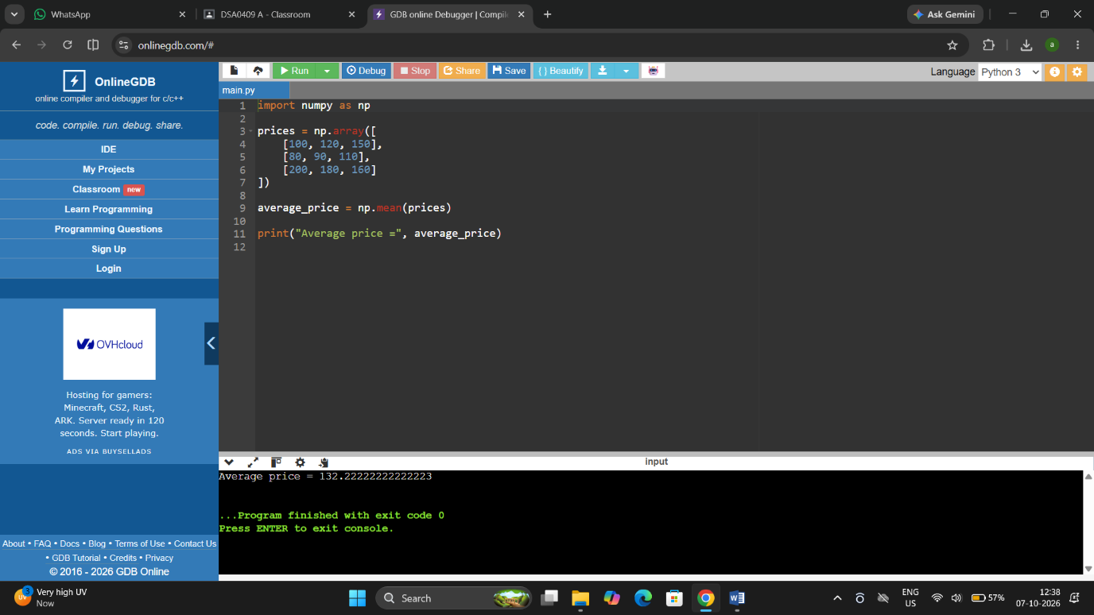

EX-3: Average Sale Price of Houses with More Than 4 Bedrooms
import numpy as np
# Columns: Bedrooms, Area, Sale Price
house_data = np.array([
[3, 1200, 250000],
[5, 1800, 400000],
[6, 2200, 500000],
[4, 1500, 320000],
[5, 2000, 450000]
])
selected = house_data[house_data[:, 0] > 4]
average_price = np.mean(selected[:, 2])
print("Average sale price =", average_price)
OUTPUT:

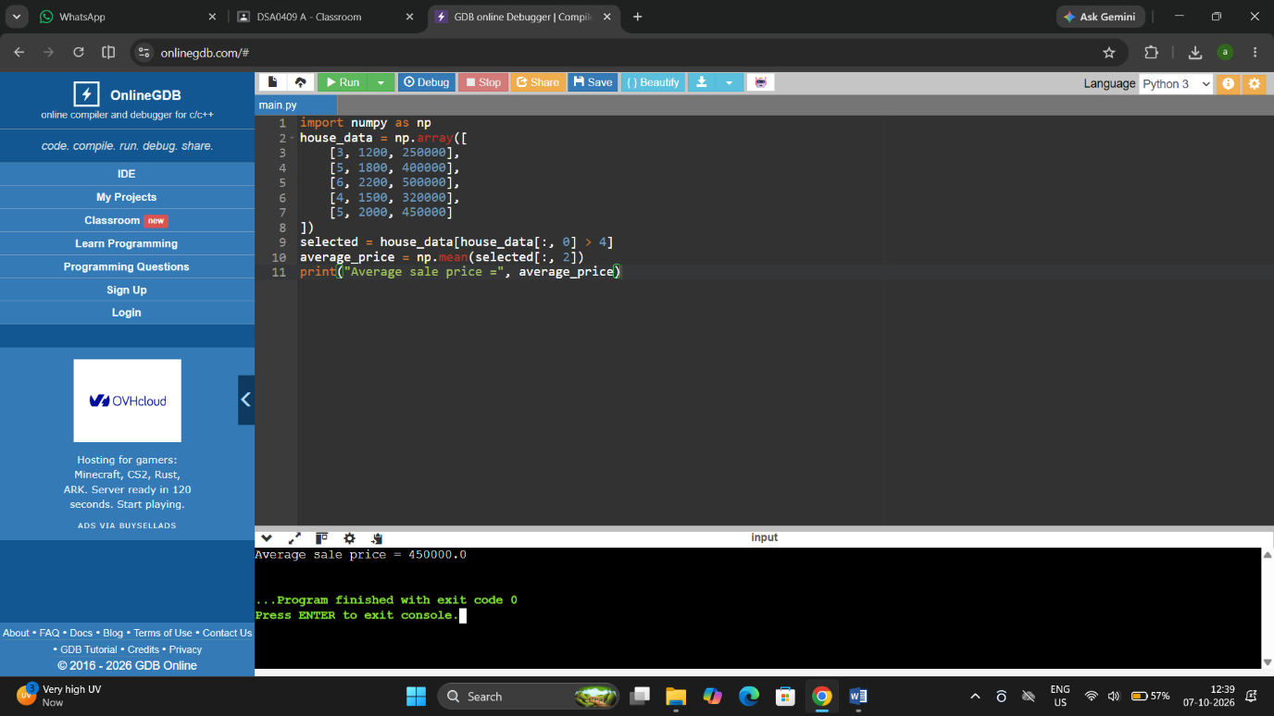

EX-4: Total Yearly Sales and Percentage Increase
import numpy as np
sales_data = np.array([10000, 12000, 15000, 18000])
total_sales = np.sum(sales_data)
percentage_increase = ((sales_data[3] - sales_data[0]) / sales_data[0]) * 100
print("Total sales =", total_sales)
print("Percentage increase =", percentage_increase, "%")
OUTPUT:

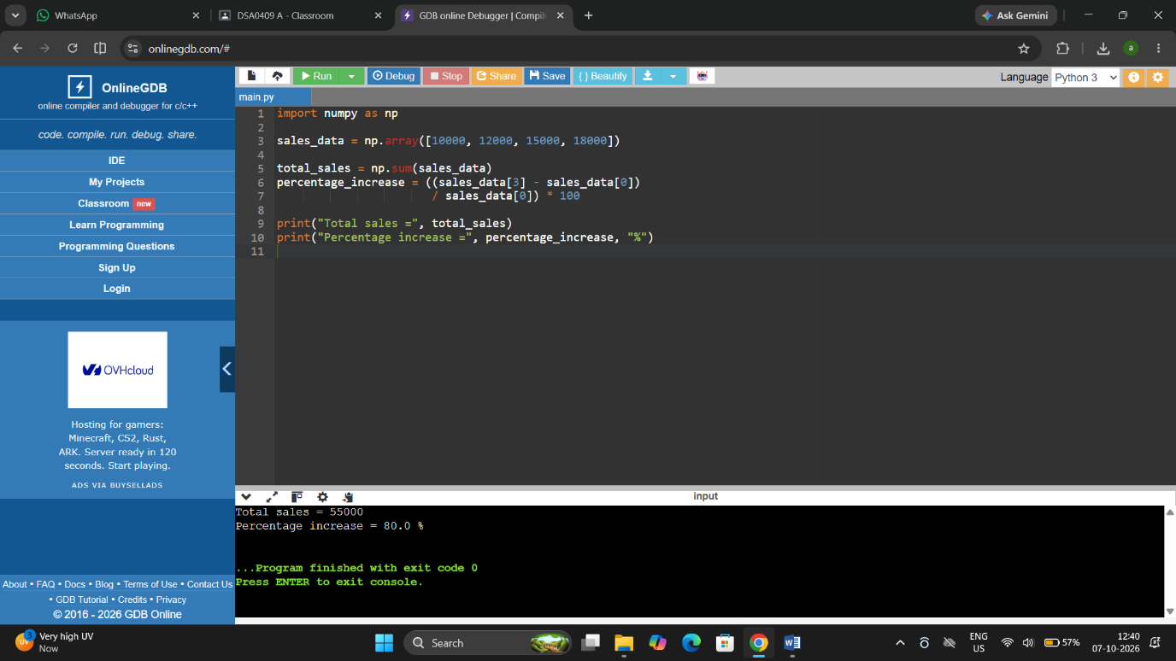

EX-5: Average Fuel Efficiency and Percentage Improvement
import numpy as np
fuel_efficiency = np.array([25, 30, 28, 35, 32])
average = np.mean(fuel_efficiency)
old_model = fuel_efficiency[0]
new_model = fuel_efficiency[1]
improvement = ((new_model - old_model) / old_model) * 100
print("Average fuel efficiency =", average)
print("Percentage improvement =", improvement, "%")
OUTPUT:

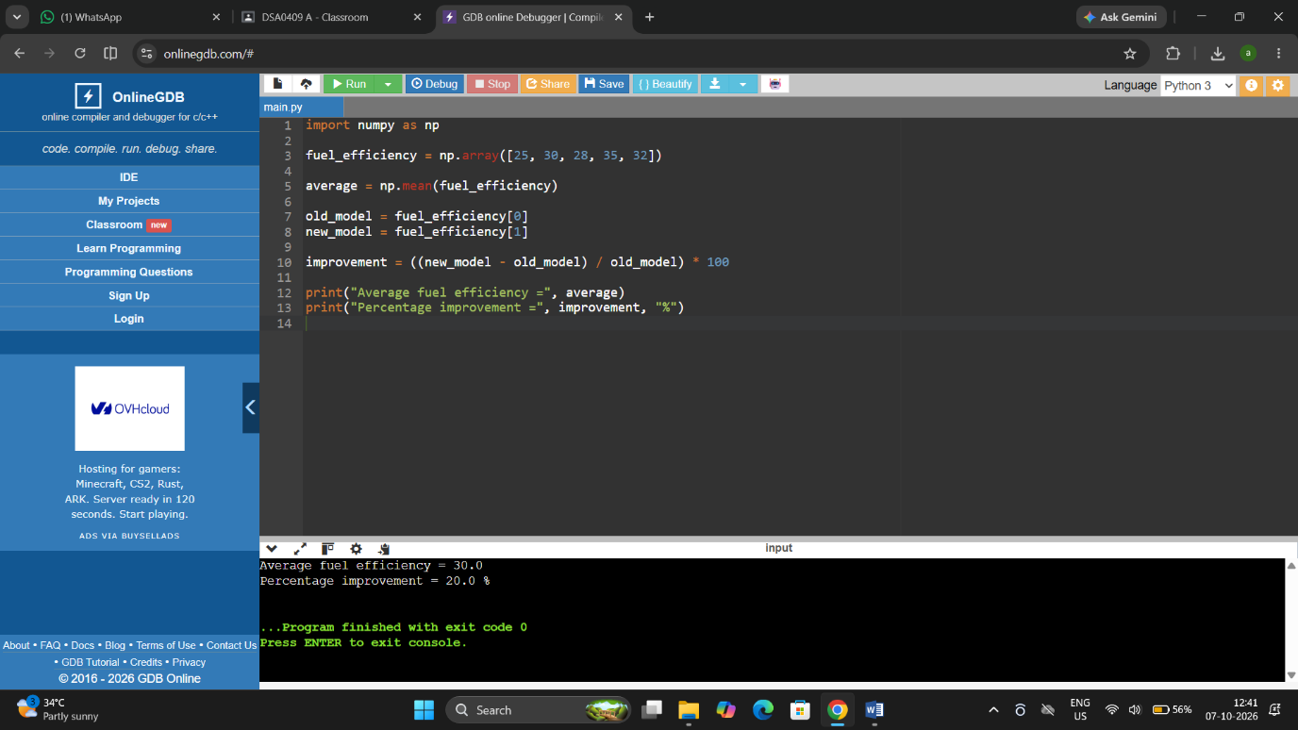

EX-6: Total Grocery Cost with Discount and Tax
prices = [100, 50, 200]
quantities = [2, 3, 1]
discount_rate = 10
tax_rate = 5
subtotal = 0
for price, quantity in zip(prices, quantities):
subtotal += price * quantity
discount = subtotal * discount_rate / 100
after_discount = subtotal - discount
tax = after_discount * tax_rate / 100
total = after_discount + tax
print("Subtotal =", subtotal)
print("Discount =", discount)
print("Tax =", tax)
print("Total cost =", total)
OUTPUT:

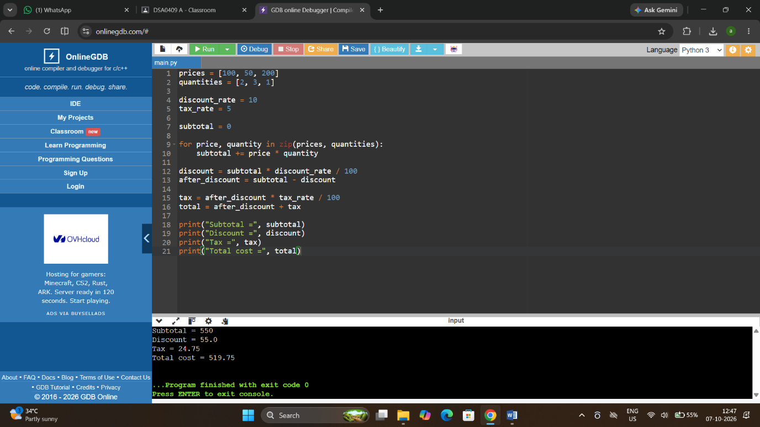

EX-7: Pandas Order Analysis
import pandas as pd
order_data = pd.DataFrame({
"Customer_ID": [1, 1, 2, 2, 3],
"Order_Date": ["2026-01-02", "2026-01-05", "2026-01-03", "2026-01-10", "2026-01-08"],
"Product": ["Pen", "Book", "Pen", "Bag", "Book"],
"Quantity": [2, 3, 5, 1, 4]
})
print("Orders by customer:")
print(order_data.groupby("Customer_ID").size())
print("Average quantity by product:")
print(order_data.groupby("Product")["Quantity"].mean())
order_data["Order_Date"] = pd.to_datetime(order_data["Order_Date"])
print("Earliest date:", order_data["Order_Date"].min())
print("Latest date:", order_data["Order_Date"].max())
OUTPUT:

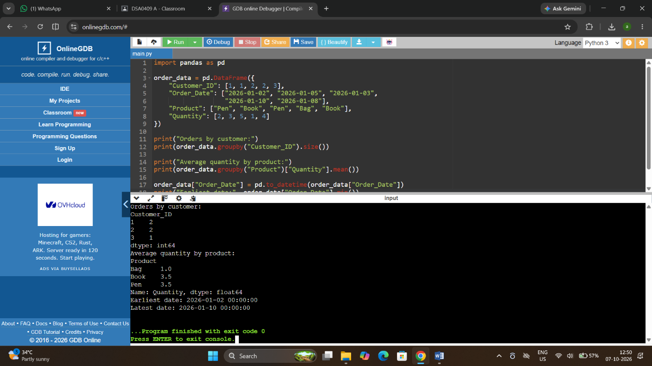

EX-8: Top 5 Products Sold
import pandas as pd
sales = pd.DataFrame({
"Product": ["Pen", "Book", "Pen", "Bag", "Book", "Pen", "Bag"],
"Quantity": [10, 8, 15, 5, 12, 20, 9]
})
top5 = sales.groupby("Product")["Quantity"].sum()
top5 = top5.sort_values(ascending=False).head(5)
print(top5)
OUTPUT:

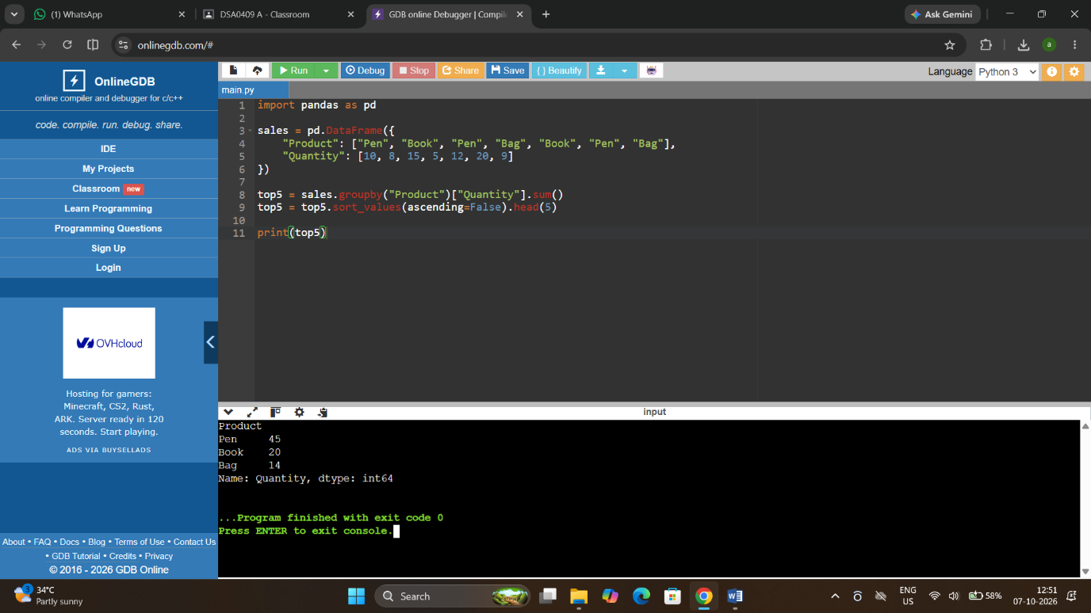

EX-9: Property Data Analysis using Pandas

import pandas as pd
property_data = pd.DataFrame({
"Location": ["Chennai", "Chennai", "Madurai", "Madurai", "Chennai"],
"Bedrooms": [3, 5, 4, 6, 5],
"Area": [1200, 1800, 1500, 2200, 2000],
"Price": [300000, 450000, 350000, 500000, 480000]
})

print("Average price by location:")
print(property_data.groupby("Location")["Price"].mean())
print("Properties with more than 4 bedrooms:")
print((property_data["Bedrooms"] > 4).sum())
largest = property_data.loc[property_data["Area"].idxmax()]
print("Property with largest area:")
print(largest)
OUTPUT:

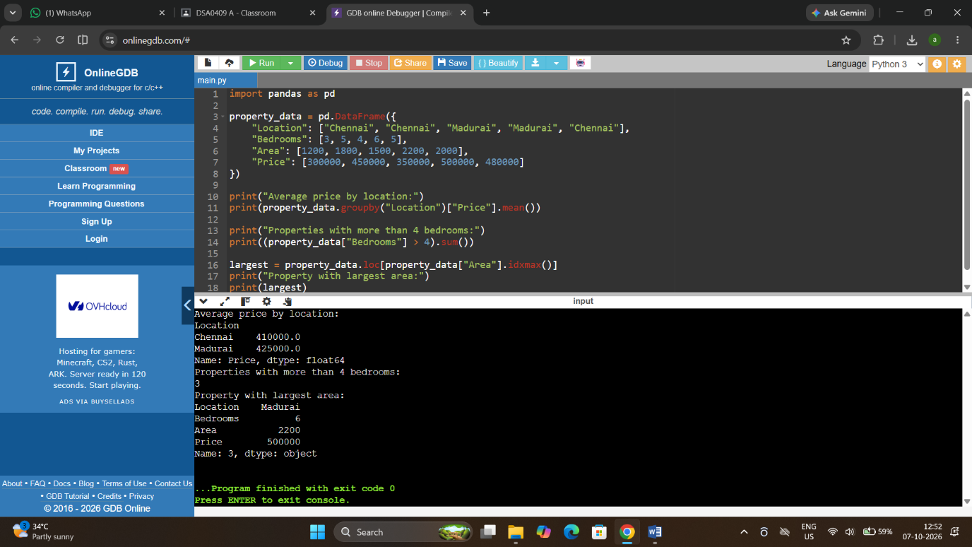

EX-10: Monthly Sales – Line Plot and Bar Plot

import matplotlib.pyplot as plt
months = ["Jan", "Feb", "Mar", "Apr", "May", "Jun"]
sales = [100, 120, 150, 130, 180, 200]
plt.plot(months, sales, marker="o")
plt.title("Monthly Sales - Line Plot")
plt.xlabel("Month")
plt.ylabel("Sales")
plt.show()
plt.bar(months, sales)
plt.title("Monthly Sales - Bar Plot")
plt.xlabel("Month")
plt.ylabel("Sales")
plt.show()
OUTPUT:
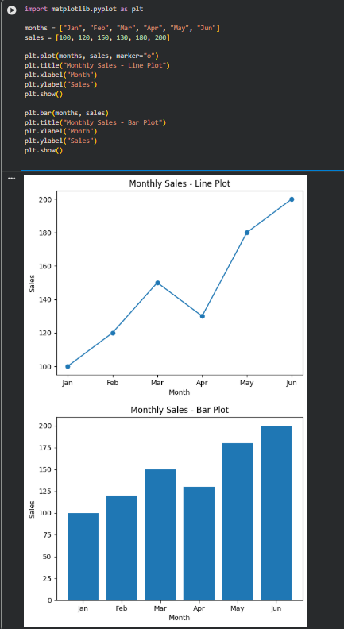

EX-11: Sales over Time – Line, Scatter and Bar Plots

import matplotlib.pyplot as plt
months = [1, 2, 3, 4, 5, 6]
sales = [100, 120, 150, 140, 180, 200]
plt.plot(months, sales, marker="o")
plt.title("Sales over Time")
plt.xlabel("Month")
plt.ylabel("Sales")
plt.show()
plt.scatter(months, sales)
plt.title("Sales - Scatter Plot")
plt.xlabel("Month")
plt.ylabel("Sales")
plt.show()
plt.bar(months, sales)
plt.title("Monthly Sales - Bar Plot")
plt.xlabel("Month")
plt.ylabel("Sales")
plt.show()
OUTPUT:
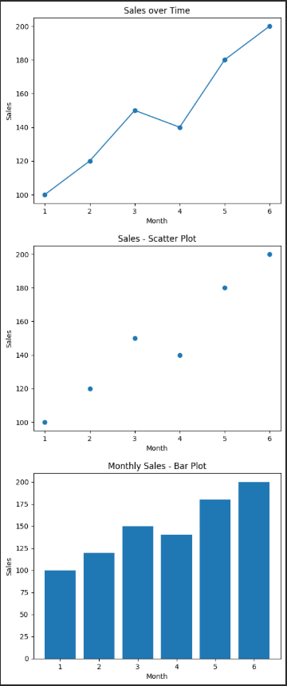

EX-12: Monthly Temperature and Rainfall Plots

import matplotlib.pyplot as plt
months = ["Jan", "Feb", "Mar", "Apr", "May", "Jun"]
temperature = [25, 27, 29, 31, 32, 30]
rainfall = [20, 15, 30, 80, 120, 100]
plt.plot(months, temperature, marker="o")
plt.title("Monthly Temperature")
plt.xlabel("Month")
plt.ylabel("Temperature")
plt.show()
plt.scatter(months, rainfall)
plt.title("Monthly Rainfall")
plt.xlabel("Month")
plt.ylabel("Rainfall")
plt.show()
OUTPUT:
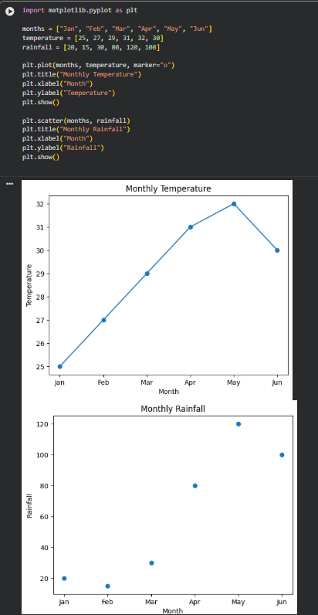

EX-13: Word Frequency from a Text File

from collections import Counter
import re
with open("sample_text.txt", "r") as file:
text = file.read().lower()
words = re.findall(r"\b\w+\b", text)
frequency = Counter(words)
for word, count in frequency.most_common():
print(word, ":", count)
OUTPUT:

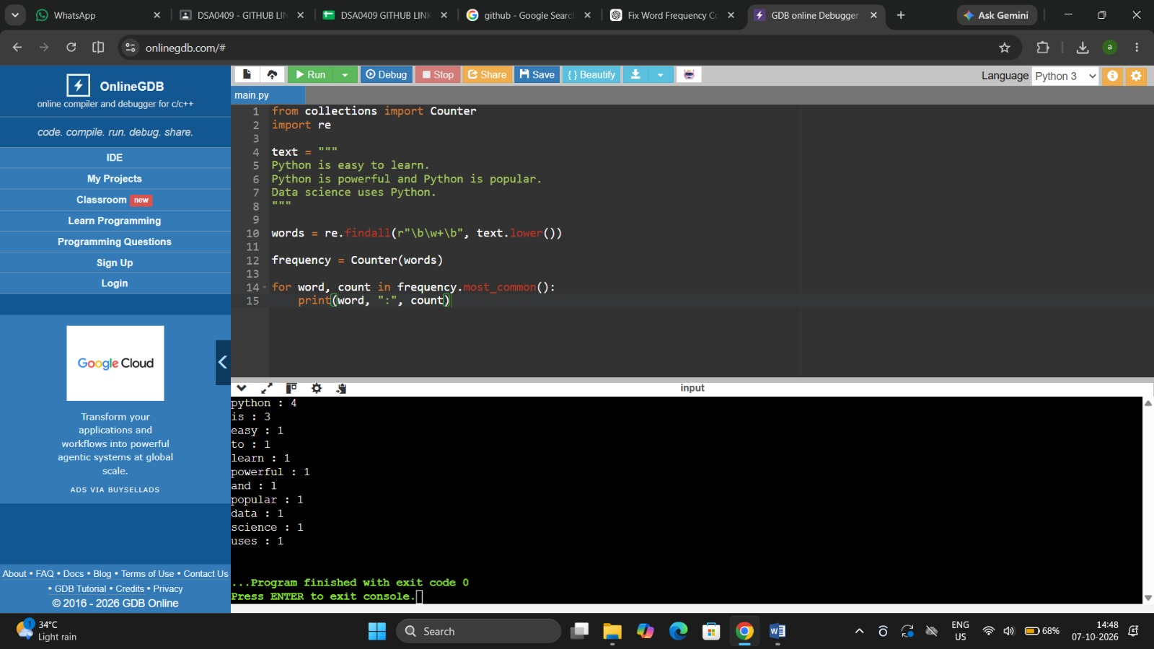

EX-14: Frequency Distribution of Customer Ages

import pandas as pd
import matplotlib.pyplot as plt
data = pd.DataFrame({
"Age": [20, 25, 20, 30, 25, 20, 35, 30, 25]
})
frequency = data["Age"].value_counts().sort_index()
print(frequency)
frequency.plot(kind="bar")
plt.title("Customer Age Frequency")
plt.xlabel("Age")
plt.ylabel("Frequency")
plt.show()
OUTPUT:
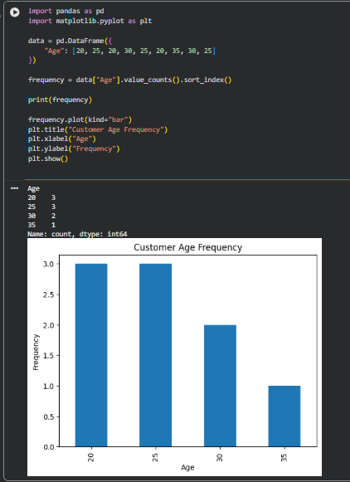

EX-15: Frequency Distribution of Likes

import pandas as pd
import matplotlib.pyplot as plt
data = pd.DataFrame({
"Likes": [10, 20, 10, 30, 20, 10, 40, 30]
})
frequency = data["Likes"].value_counts().sort_index()
print(frequency)
frequency.plot(kind="bar")
plt.title("Frequency of Likes")
plt.xlabel("Likes")
plt.ylabel("Number of Posts")
plt.show()
OUTPUT:
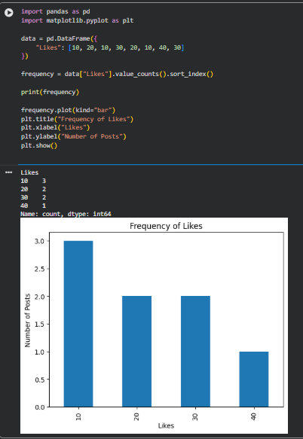

EX-16: Word Frequency in Customer Reviews

import pandas as pd
import re
from collections import Counter
reviews = pd.DataFrame({
"Review": [
"good product and good service",
"excellent product",
"good quality product"
]
})
words = []
for review in reviews["Review"]:
words.extend(re.findall(r"\b\w+\b", review.lower()))
frequency = Counter(words)
for word, count in frequency.most_common():
print(word, ":", count)
OUTPUT:
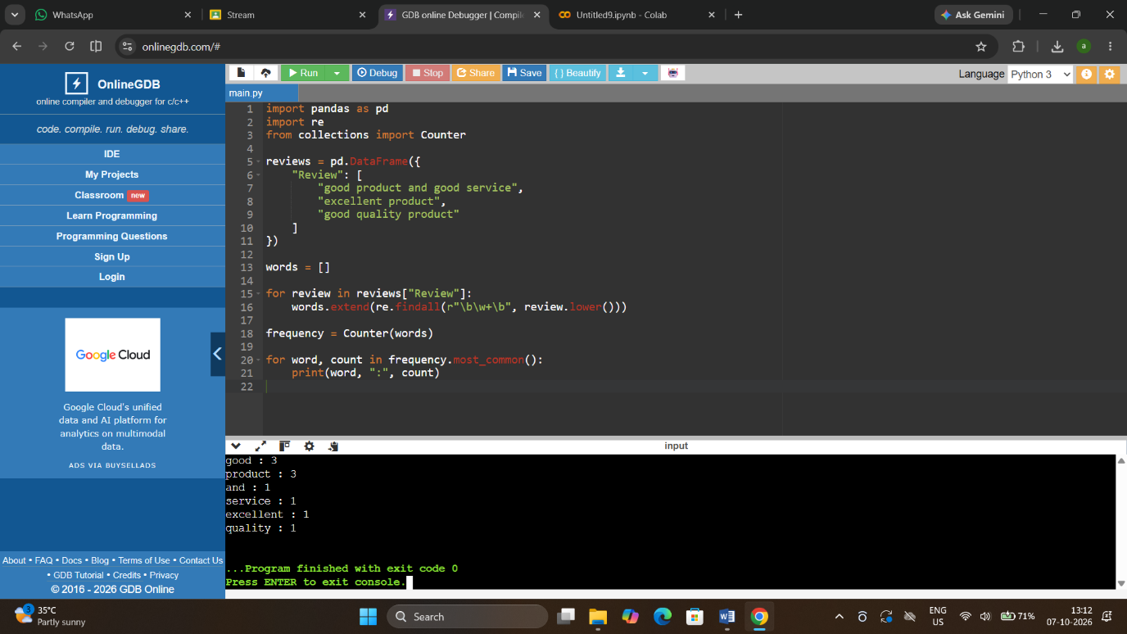

EX-17: Customer Feedback – Top N Word Frequency

import pandas as pd
import re
from collections import Counter
import matplotlib.pyplot as plt
data = pd.read_csv("data.csv")
stop_words = {"the", "and", "is", "a", "an", "of", "to", "in"}
words = []
for text in data["feedback"].dropna():
text = text.lower()
words.extend(re.findall(r"\b[a-z]+\b", text))
words = [word for word in words if word not in stop_words]
frequency = Counter(words)
n = int(input("Enter N: "))
top_words = frequency.most_common(n)
print(top_words)
names = [x[0] for x in top_words]
counts = [x[1] for x in top_words]
plt.bar(names, counts)
plt.xticks(rotation=45)
plt.title("Top Words in Customer Feedback")
plt.show()
OUTPUT:
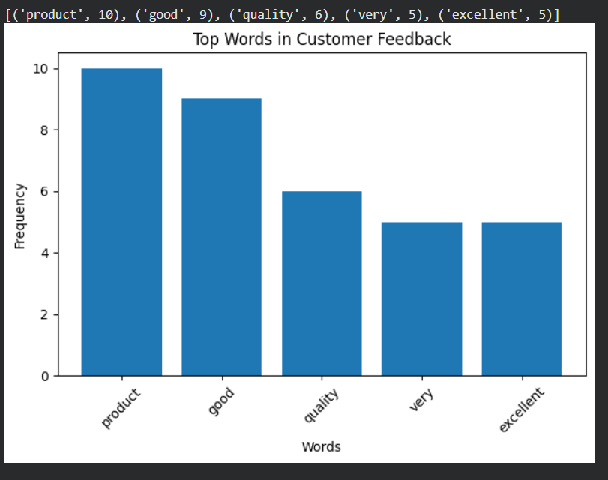

EX-18: Mean, Median, Standard Deviation, Boxplot, Scatter Plot and Q-Q Plot

import pandas as pd
import matplotlib.pyplot as plt
import scipy.stats as stats

data = pd.DataFrame({
"Age": [20, 22, 25, 28, 30, 32, 35, 40],
"Fat": [15, 18, 20, 22, 24, 27, 30, 32]
})

print("Mean:")
print(data.mean())

print("Median:")
print(data.median())

print("Standard deviation:")
print(data.std())

data[["Age", "Fat"]].boxplot()
plt.title("Boxplots")
plt.show()

plt.scatter(data["Age"], data["Fat"])
plt.xlabel("Age")
plt.ylabel("Body Fat")
plt.title("Age vs Body Fat")
plt.show()

stats.probplot(data["Age"], dist="norm", plot=plt)
plt.title("Q-Q Plot of Age")
plt.show()

OUTPUT:
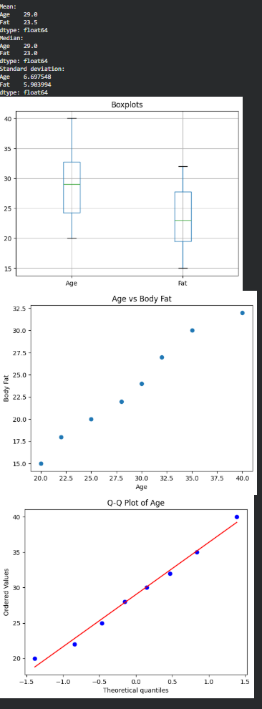

EX-19: 95% Confidence Interval for Blood Pressure Reduction

import numpy as np
from scipy import stats

drug = np.array([8, 10, 12, 9, 11, 13, 10, 12])
placebo = np.array([3, 5, 4, 6, 2, 5, 4, 3])

def confidence_interval(data):
mean = np.mean(data)
sem = stats.sem(data)
interval = stats.t.interval(
0.95, len(data) - 1, loc=mean, scale=sem
)
return interval

print("Drug 95% CI:", confidence_interval(drug))
print("Placebo 95% CI:", confidence_interval(placebo))
OUTPUT:

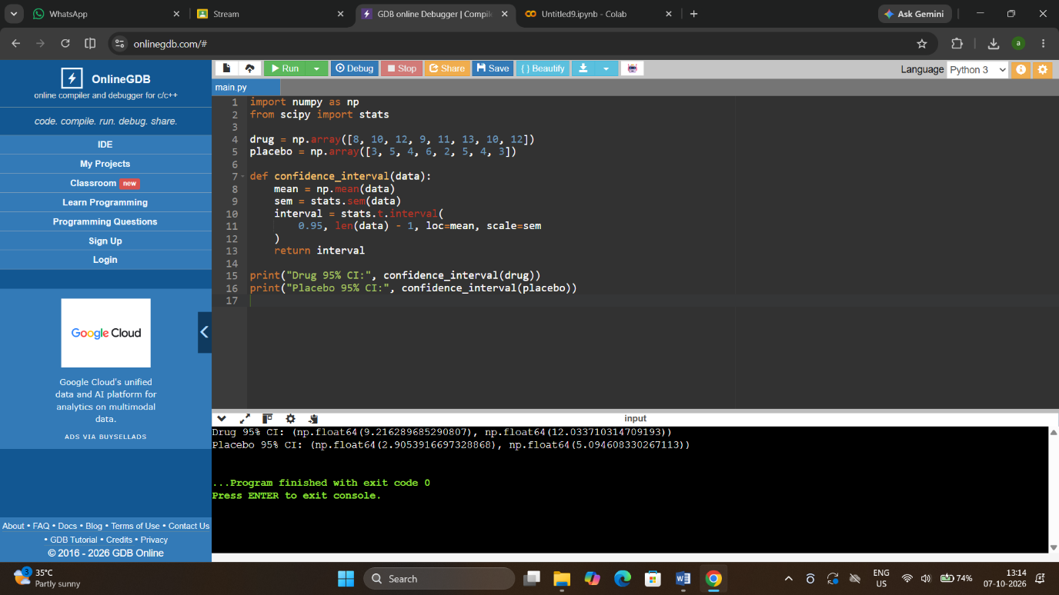

EX-20: A/B Test – Compare Two Conversion Rate Samples

import numpy as np
from scipy.stats import ttest_ind

design_A = np.array([0.10, 0.12, 0.11, 0.13, 0.09, 0.12])
design_B = np.array([0.14, 0.15, 0.13, 0.16, 0.12, 0.14])

t_stat, p_value = ttest_ind(design_A, design_B)
print("t-statistic =", t_stat)
print("p-value =", p_value)

if p_value < 0.05:
print("Statistically significant difference")
else:
print("No statistically significant difference")
OUTPUT:

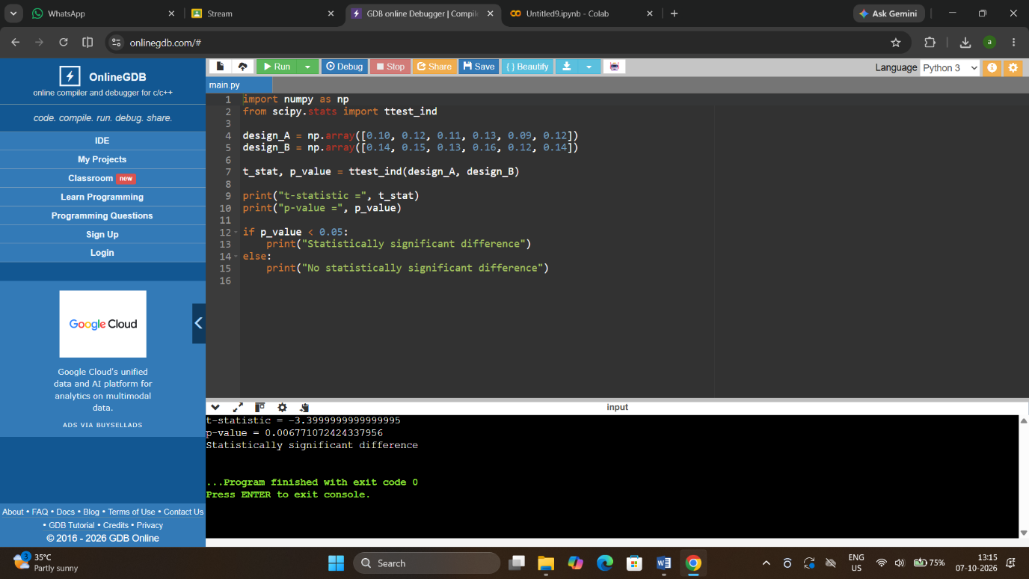
EX-21: Point Estimate and Confidence Interval from CSV

import pandas as pd
import numpy as np
from scipy import stats

data = pd.read_csv("rare_elements.csv")
values = data.iloc[:, 0].dropna()

n = int(input("Enter sample size: "))
confidence = float(input("Enter confidence level (for example 0.95): "))
precision = float(input("Enter desired precision: "))

sample = values.sample(n=min(n, len(values)), random_state=1)
mean = sample.mean()
sem = stats.sem(sample)
ci = stats.t.interval(
confidence, len(sample) - 1, loc=mean, scale=sem
)

print("Point estimate =", mean)
print("Confidence interval =", ci)
print("Desired precision =", precision)
OUTPUT:
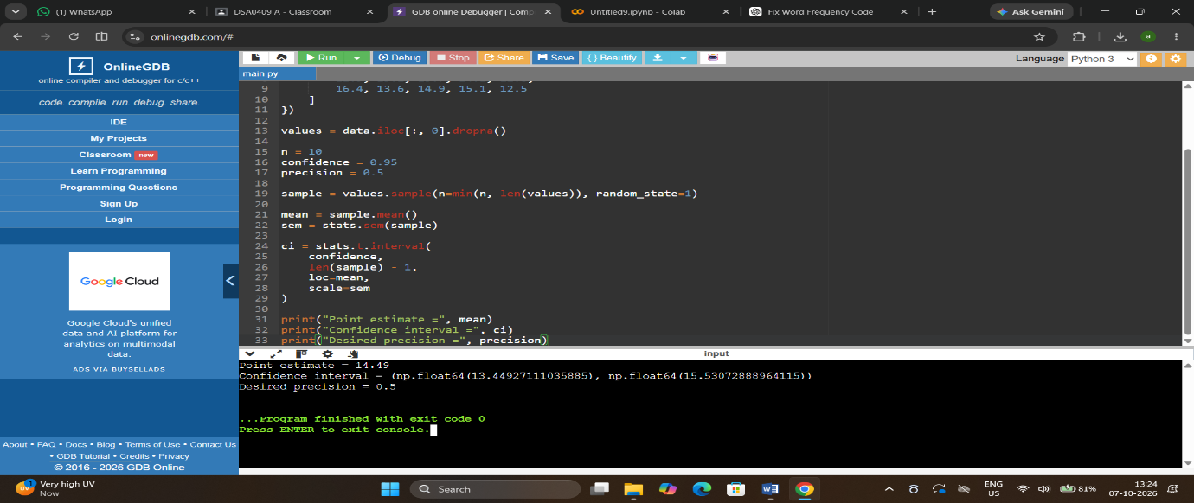

EX-22: Confidence Interval for Mean Customer Rating

import pandas as pd
from scipy import stats

data = pd.read_csv("customer_reviews.csv")
ratings = data["rating"].dropna()

confidence = 0.95
mean = ratings.mean()
sem = stats.sem(ratings)
ci = stats.t.interval(
confidence, len(ratings) - 1,
loc=mean, scale=sem
)

print("Mean rating =", mean)
print("95% Confidence interval =", ci)
OUTPUT:

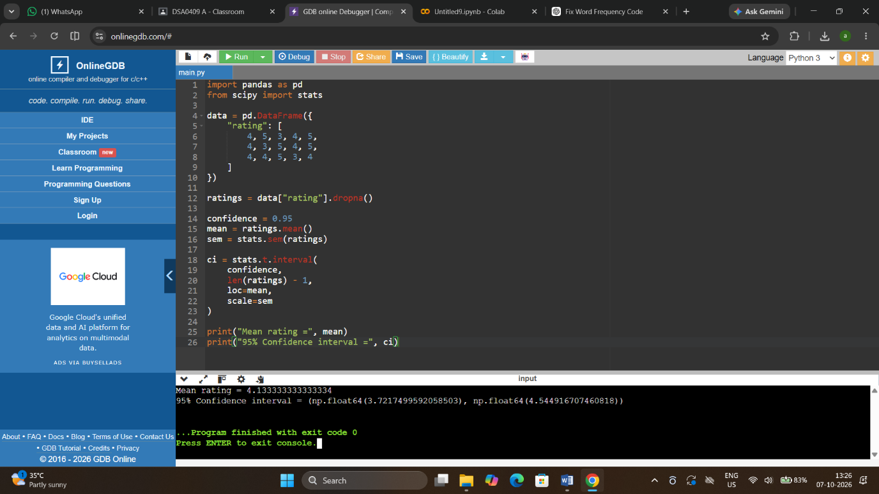

EX-23: Hypothesis Testing for Treatment vs Placebo

import numpy as np
from scipy.stats import ttest_ind
import matplotlib.pyplot as plt

control = np.array([5, 6, 7, 5, 6, 4, 7])
treatment = np.array([8, 9, 10, 9, 11, 8, 10])

t_stat, p_value = ttest_ind(treatment, control)
print("t-statistic =", t_stat)
print("p-value =", p_value)

if p_value < 0.05:
print("Significant difference")
else:
print("No significant difference")

plt.boxplot([control, treatment], labels=["Control", "Treatment"])
plt.title("Treatment vs Control")
plt.show()
OUTPUT:

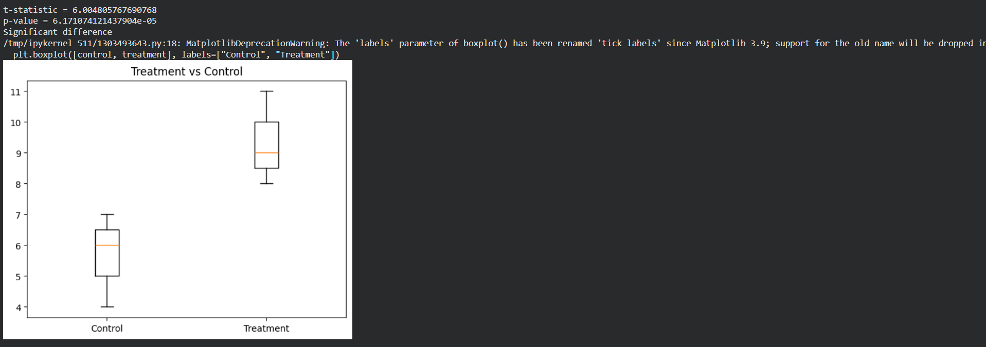

EX-24: KNN Classifier for a New Patient

from sklearn.neighbors import KNeighborsClassifier

# Features: symptom1, symptom2
X = [
[1, 1], [1, 2], [2, 1],
[8, 8], [9, 8], [8, 9]
]
# 0 = No condition, 1 = Condition
y = [0, 0, 0, 1, 1, 1]
model = KNeighborsClassifier(n_neighbors=3)
model.fit(X, y)

patient = [[7, 8]]
prediction = model.predict(patient)

if prediction[0] == 1:
print("Patient may have the condition")
else:
print("Patient may not have the condition")
OUTPUT:
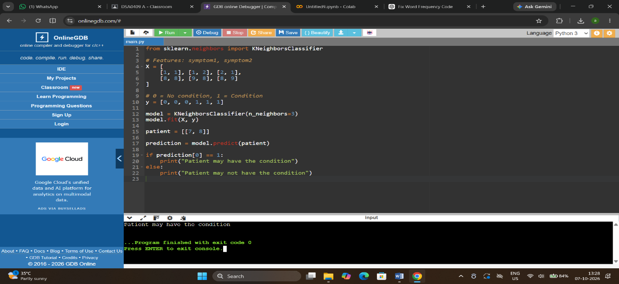

EX-25: Decision Tree for Iris Classification

from sklearn.datasets import load_iris
from sklearn.tree import DecisionTreeClassifier
iris = load_iris()
X = iris.data
y = iris.target
model = DecisionTreeClassifier(random_state=1)
model.fit(X, y)
sepal_length = float(input("Sepal length: "))
sepal_width = float(input("Sepal width: "))
petal_length = float(input("Petal length: "))
petal_width = float(input("Petal width: "))
new_flower = [[
sepal_length, sepal_width,
petal_length, petal_width
]]
prediction = model.predict(new_flower)
print("Predicted species:", iris.target_names[prediction[0]])
OUTPUT:

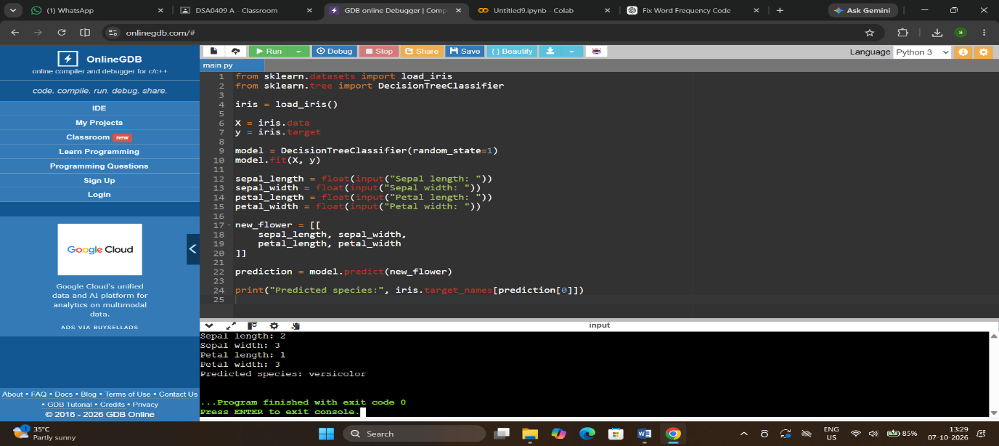

EX-26: Linear Regression for Housing Price Prediction

import numpy as np
from sklearn.linear_model import LinearRegression

# Area in square feet
X = np.array([[1000], [1200], [1500], [1800], [2000]])
# House prices
y = np.array([200000, 240000, 300000, 360000, 400000])

model = LinearRegression()
model.fit(X, y)

area = float(input("Enter house area: "))
prediction = model.predict([[area]])
print("Predicted house price =", prediction[0])
OUTPUT:

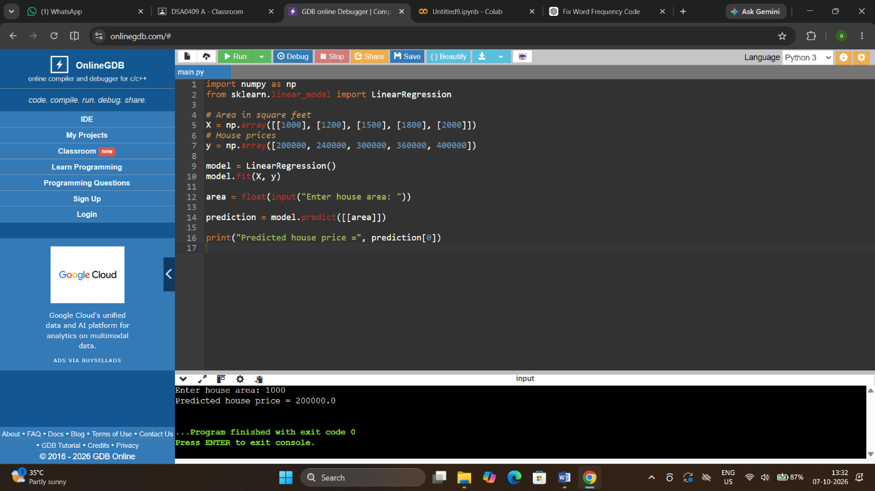

EX-27: Logistic Regression for Customer Churn
import numpy as np
from sklearn.linear_model import LogisticRegression
# Features: usage minutes, contract months
X = np.array([
[100, 24], [120, 24], [80, 12],
[300, 6], [280, 6], [350, 3]
])
# 0 = Not churned, 1 = Churned
y = np.array([0, 0, 0, 1, 1, 1])
model = LogisticRegression()
model.fit(X, y)
usage = float(input("Usage minutes: "))
contract = float(input("Contract duration: "))
prediction = model.predict([[usage, contract]])
if prediction[0] == 1:
print("Customer may churn")
else:
print("Customer may not churn")
OUTPUT:
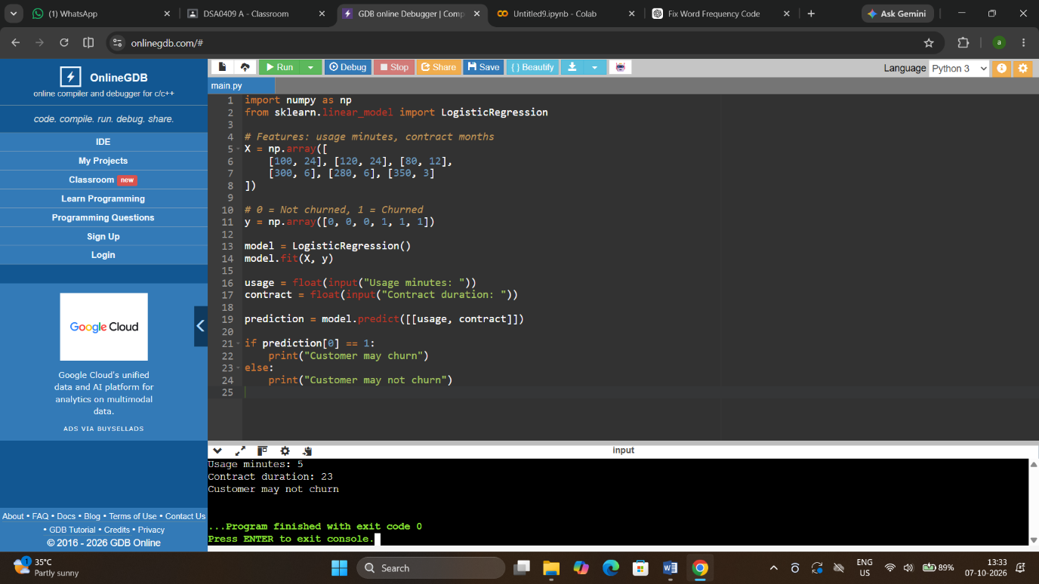

EX-28: K-Means Customer Segmentation
import numpy as np
from sklearn.cluster import KMeans

X = np.array([
[1000, 2],
[1200, 3],
[1100, 2],
[5000, 10],
[5200, 11],
[4800, 9]
])

model = KMeans(n_clusters=2, random_state=1, n_init=10)
model.fit(X)
new_customer = [[1500, 3]]
cluster = model.predict(new_customer)
print("Customer belongs to cluster:", cluster[0])
OUTPUT:
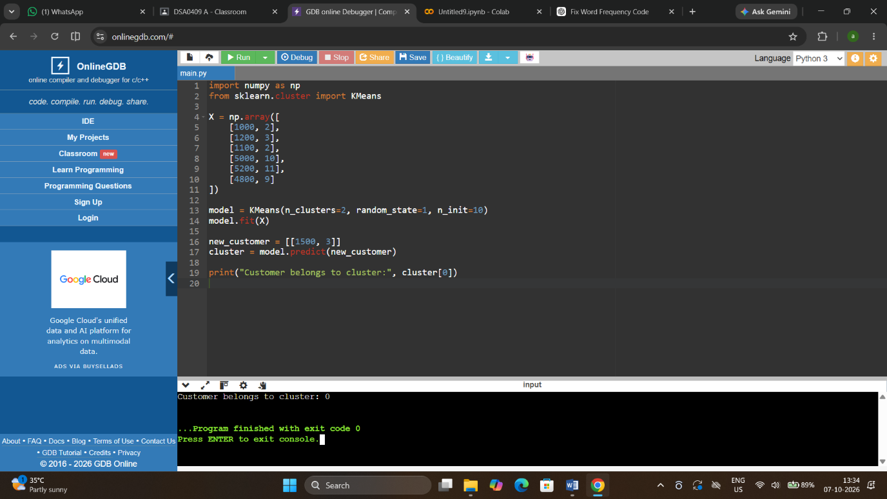
EX-29: Accuracy, Precision, Recall and F1-Score

from sklearn.metrics import (
accuracy_score, precision_score,
recall_score, f1_score
)

# Actual and predicted values
y_test = [0, 1, 1, 0, 1, 0, 1, 1]
y_pred = [0, 1, 0, 0, 1, 0, 1, 0]

print("Accuracy =", accuracy_score(y_test, y_pred))
print("Precision =", precision_score(y_test, y_pred))
print("Recall =", recall_score(y_test, y_pred))
print("F1-score =", f1_score(y_test, y_pred))
OUTPUT:
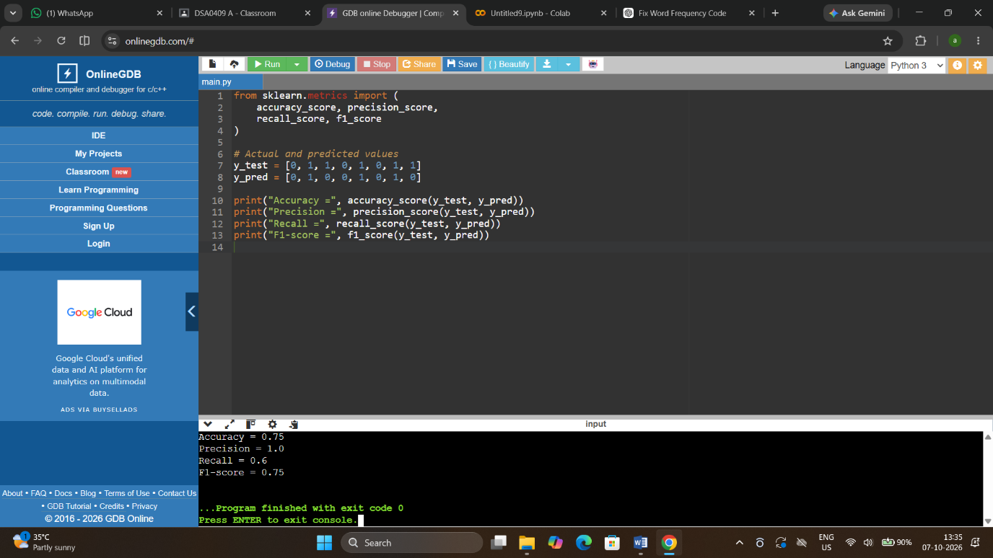

EX-30: CART Regression for Used Car Price

import numpy as np
from sklearn.tree import DecisionTreeRegressor
# Features: mileage, age
X = np.array([
[20000, 2], [30000, 3], [40000, 4],
[60000, 5], [80000, 7], [100000, 9]
])
price = np.array([18000, 17000, 15000, 13000, 10000, 7000])

model = DecisionTreeRegressor(max_depth=3, random_state=1)
model.fit(X, price)

mileage = float(input("Mileage: "))
age = float(input("Age: "))
prediction = model.predict([[mileage, age]])
print("Predicted price =", prediction[0])
OUTPUT:

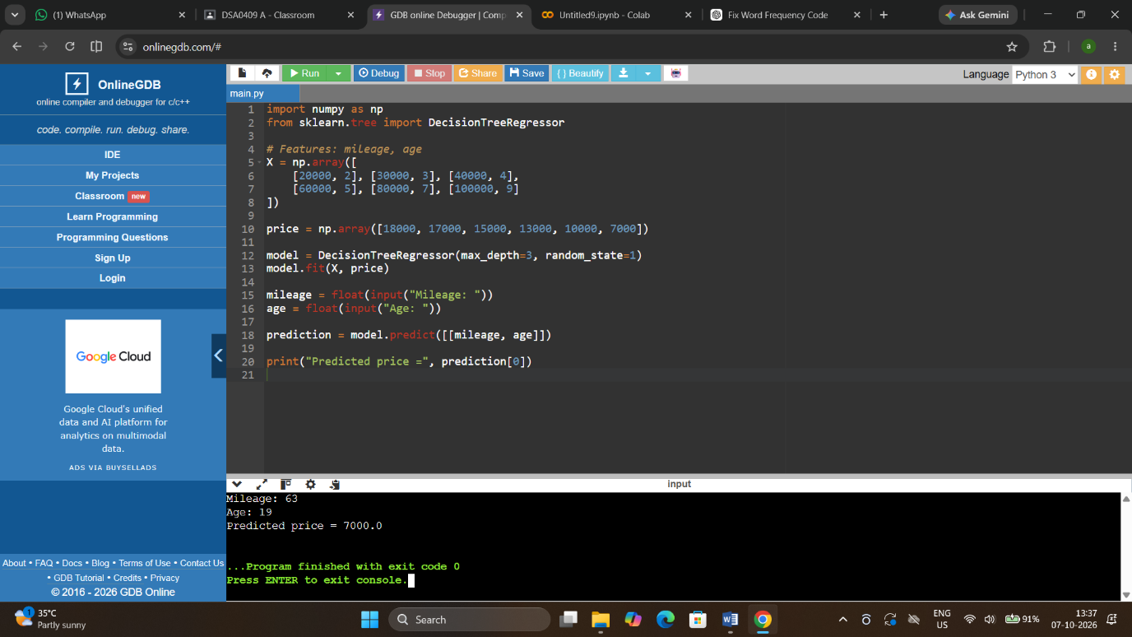
EX-31: Customer Segmentation using K-Means

import pandas as pd
import matplotlib.pyplot as plt
from sklearn.cluster import KMeans

data = pd.DataFrame({
"Spending": [1000, 1200, 1100, 5000, 5200, 4800],
"Visits": [2, 3, 2, 10, 11, 9]
})

model = KMeans(n_clusters=2, random_state=1, n_init=10)
data["Cluster"] = model.fit_predict(
data[["Spending", "Visits"]]
)

print(data)

plt.scatter(
data["Spending"],
data["Visits"],
c=data["Cluster"]
)
plt.xlabel("Spending")
plt.ylabel("Visits")
plt.title("Customer Segmentation")
plt.show()

OUTPUT:
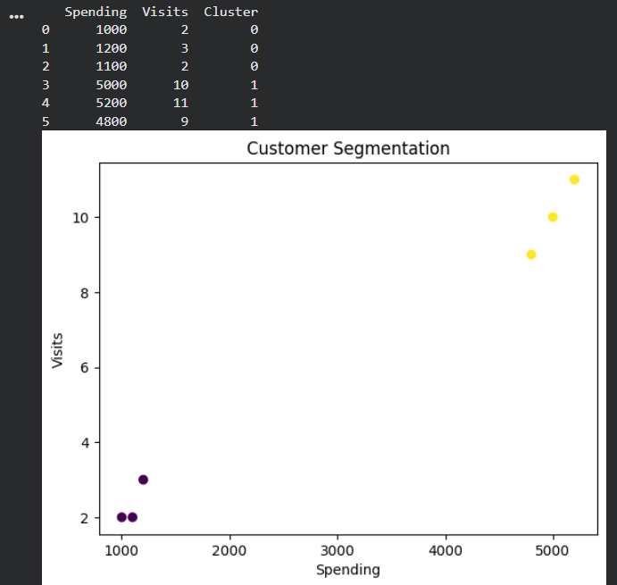

EX-32: Bivariate Analysis and Linear Regression for House Price
import pandas as pd
import matplotlib.pyplot as plt
from sklearn.linear_model import LinearRegression
from sklearn.metrics import r2_score
data = pd.DataFrame({
"Size": [800, 1000, 1200, 1500, 1800, 2000],
"Price": [160, 200, 240, 300, 360, 400]
})

X = data[["Size"]]
y = data["Price"]
model = LinearRegression()
model.fit(X, y)
predicted = model.predict(X)
print("R-squared =", r2_score(y, predicted))
plt.scatter(data["Size"], data["Price"])
plt.plot(data["Size"], predicted)
plt.xlabel("House Size")
plt.ylabel("Price")
plt.title("House Size vs Price")
plt.show()
new_size = float(input("Enter house size: "))
print("Predicted price =", model.predict([[new_size]])[0])
OUTPUT:
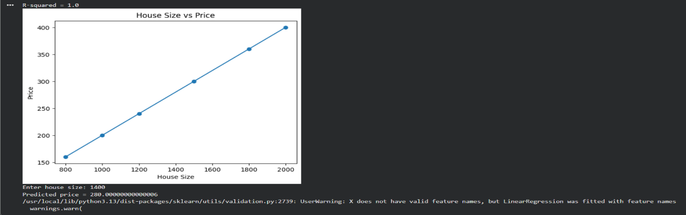
EX-33: Multiple Linear Regression for Car Price

import pandas as pd
from sklearn.linear_model import LinearRegression
from sklearn.metrics import r2_score

data = pd.DataFrame({
"Engine": [1.2, 1.5, 1.8, 2.0, 2.2, 2.5],
"Horsepower": [80, 100, 120, 140, 160, 190],
"Mileage": [20, 18, 16, 15, 13, 11],
"Price": [8000, 10000, 13000, 16000, 19000, 23000]
})

X = data[["Engine", "Horsepower", "Mileage"]]
y = data["Price"]

model = LinearRegression()
model.fit(X, y)

predicted = model.predict(X)
print("R-squared =", r2_score(y, predicted))
print("Coefficients =", model.coef_)

new_car = [[1.8, 120, 16]]
print("Predicted price =", model.predict(new_car)[0])

OUTPUT:

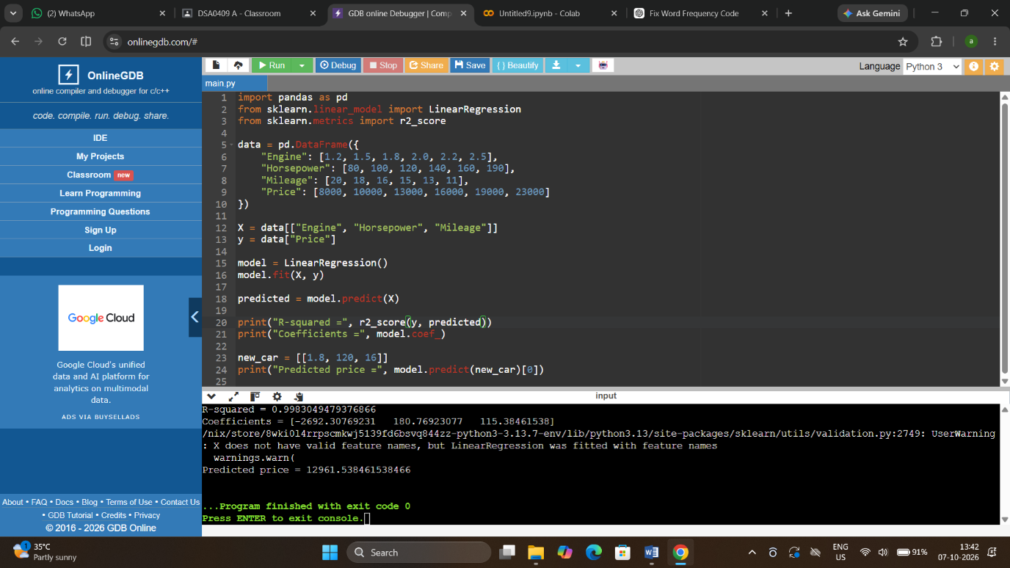

EX-34: KNN Classification with Evaluation Metrics

import numpy as np
from sklearn.model_selection import train_test_split
from sklearn.neighbors import KNeighborsClassifier
from sklearn.metrics import (
accuracy_score, precision_score,
recall_score, f1_score
)

X = np.array([
[20, 120], [22, 130], [25, 125], [27, 140],
[40, 180], [42, 190], [45, 185], [48, 200]
])
y = np.array([0, 0, 0, 0, 1, 1, 1, 1])

X_train, X_test, y_train, y_test = train_test_split(
X, y, test_size=0.25, random_state=1
)

model = KNeighborsClassifier(n_neighbors=3)
model.fit(X_train, y_train)

y_pred = model.predict(X_test)
print("Accuracy =", accuracy_score(y_test, y_pred))
print("Precision =", precision_score(y_test, y_pred))
print("Recall =", recall_score(y_test, y_pred))
print("F1-score =", f1_score(y_test, y_pred))

new_patient = [[30, 150]]
print("Prediction =", model.predict(new_patient))

OUTPUT:

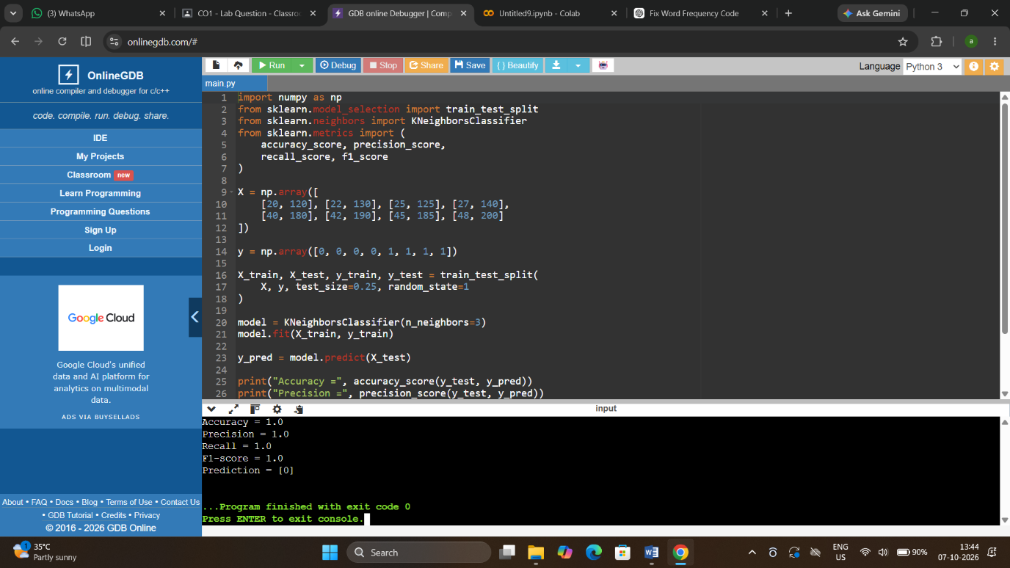

EX-35: K-Means Clustering for Retail Customers

import pandas as pd
from sklearn.cluster import KMeans

data = pd.DataFrame({
"Spending": [500, 700, 600, 4000, 4500, 4200, 1500, 1700],
"Visits": [2, 3, 2, 10, 12, 11, 5, 6]
})

model = KMeans(n_clusters=3, random_state=1, n_init=10)
data["Cluster"] = model.fit_predict(
data[["Spending", "Visits"]]
)

print(data)
print("Cluster centers:")
print(model.cluster_centers_)
OUTPUT:
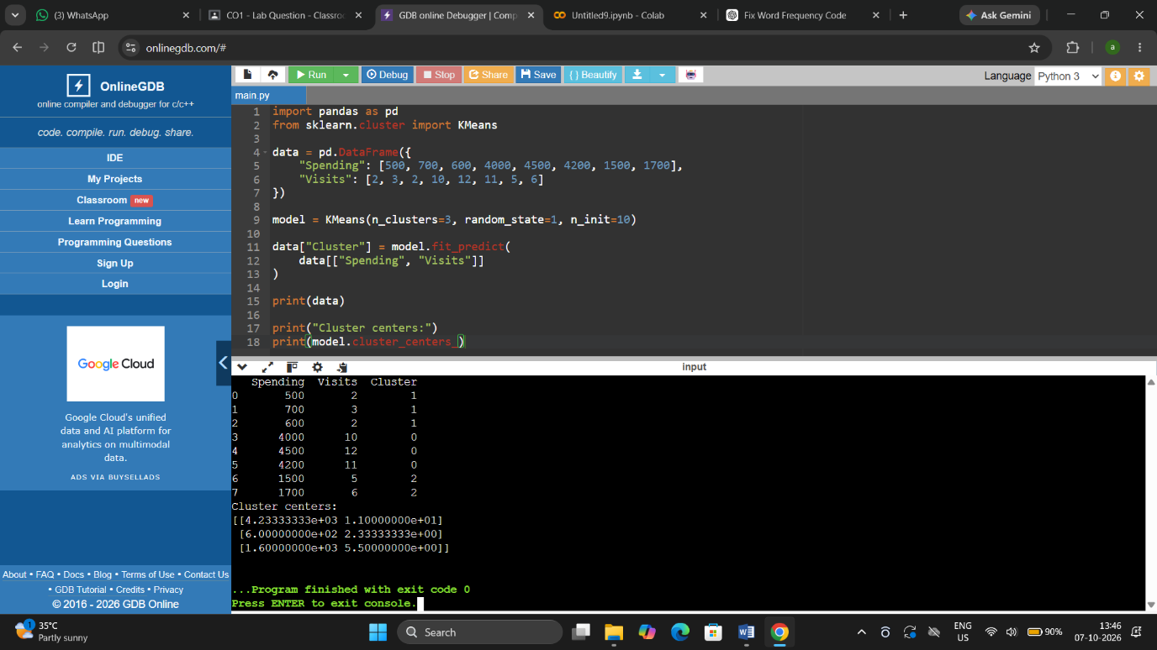

EX-36: Stock Price Variability from CSV

import pandas as pd
import matplotlib.pyplot as plt
data = pd.read_csv("stock_data.csv")
prices = data["Close"]
print("Mean =", prices.mean())
print("Standard deviation =", prices.std())
print("Minimum =", prices.min())
print("Maximum =", prices.max())
print("Range =", prices.max() - prices.min())
plt.plot(prices)
plt.title("Stock Closing Prices")
plt.xlabel("Trading Day")
plt.ylabel("Closing Price")
plt.show()
OUTPUT:

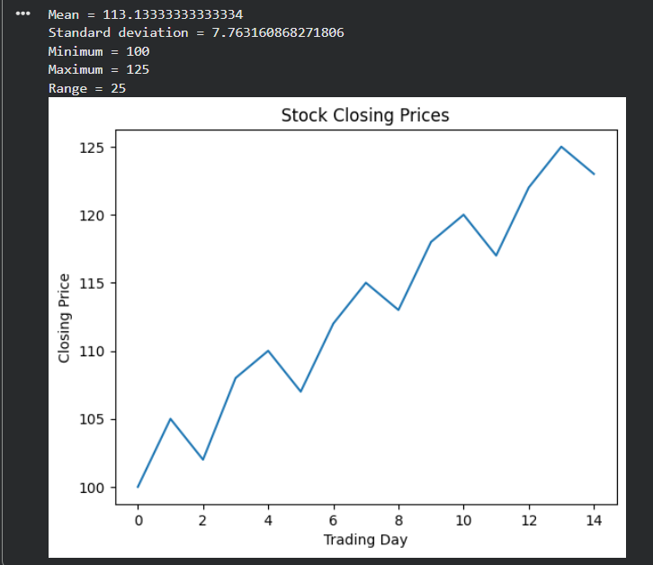
EX-37: Correlation between Study Time and Exam Score

import pandas as pd
import matplotlib.pyplot as plt
data = pd.DataFrame({
"Study_Hours": [1, 2, 3, 4, 5, 6, 7],
"Score": [45, 50, 58, 65, 72, 80, 88]
})
correlation = data["Study_Hours"].corr(data["Score"])
print("Correlation =", correlation)

plt.scatter(data["Study_Hours"], data["Score"])
plt.xlabel("Study Hours")
plt.ylabel("Exam Score")
plt.title("Study Time vs Exam Score")
plt.show()
OUTPUT:
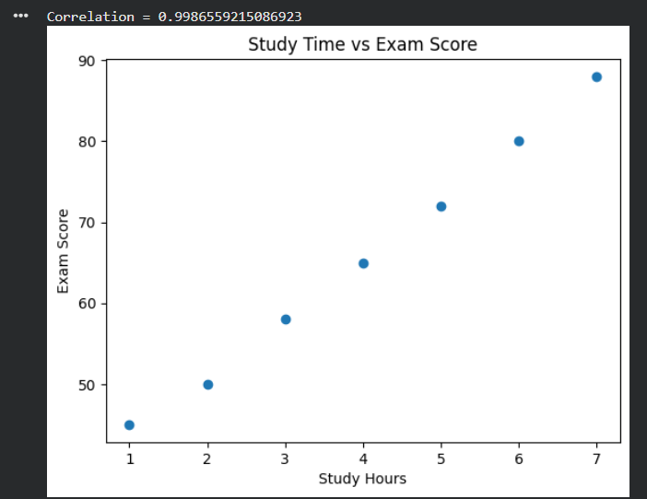
EX-38: Temperature Analysis for Different Cities

import numpy as np

# Rows = cities, columns = daily readings
temperatures = np.array([
[25, 27, 30, 28, 26],
[20, 21, 22, 21, 20],
[30, 32, 35, 33, 31]
])

cities = ["Chennai", "Bengaluru", "Delhi"]

mean = np.mean(temperatures, axis=1)
std = np.std(temperatures, axis=1)
temperature_range = np.ptp(temperatures, axis=1)

for i in range(3):
print(cities[i])
print("Mean =", mean[i])
print("Standard deviation =", std[i])
print("Range =", temperature_range[i])

highest_range = np.argmax(temperature_range)
most_consistent = np.argmin(std)

print("Highest temperature range:", cities[highest_range])
print("Most consistent city:", cities[most_consistent])

OUTPUT:

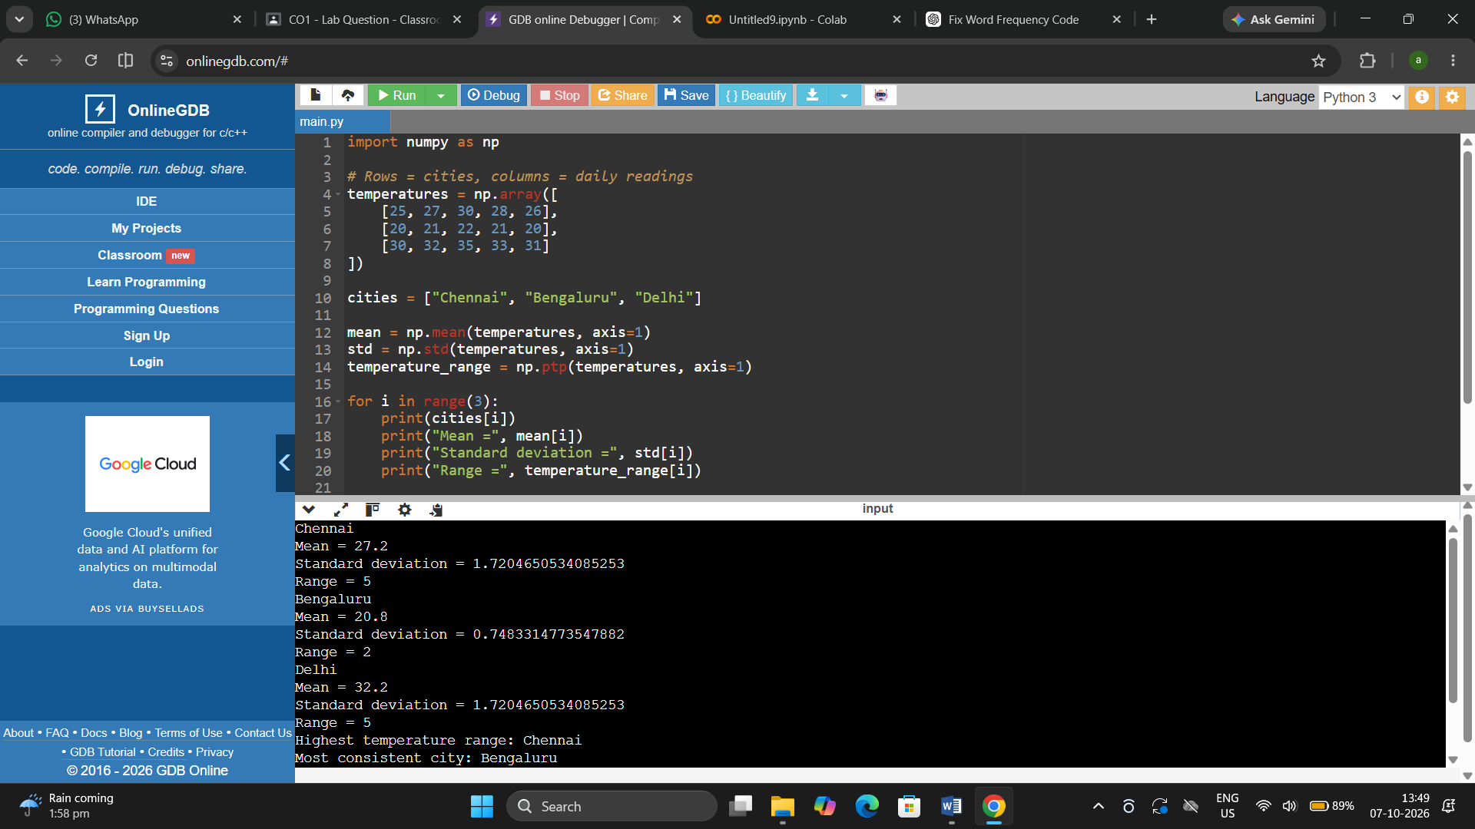

EX-39: K-Means Clustering and Visualization

import pandas as pd
import matplotlib.pyplot as plt
from sklearn.cluster import KMeans

data = pd.DataFrame({
"Spending": [500, 600, 550, 3000, 3200, 3100, 1500, 1600],
"Items": [2, 3, 2, 10, 11, 9, 5, 6]
})

model = KMeans(n_clusters=3, random_state=1, n_init=10)
data["Cluster"] = model.fit_predict(
data[["Spending", "Items"]]
)

print(data)

plt.scatter(
data["Spending"],
data["Items"],
c=data["Cluster"]
)
plt.xlabel("Total Spending")
plt.ylabel("Number of Items")
plt.title("Customer Segments")
plt.show()

OUTPUT:
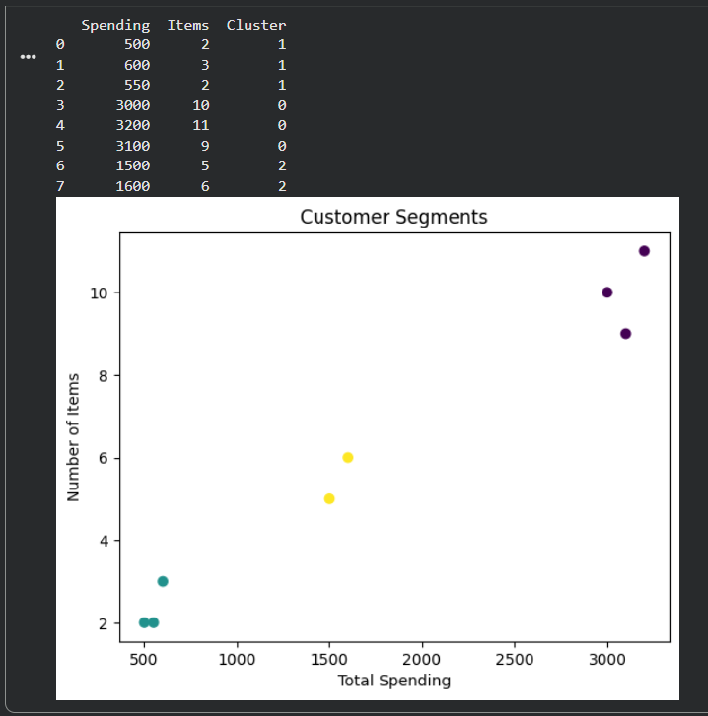

EX-40: Soccer Player Analysis using Pandas

import pandas as pd
import matplotlib.pyplot as plt
# Create and save the dataset
data = pd.DataFrame({
"Name": ["A", "B", "C", "D", "E", "F", "G"],
"Age": [22, 25, 28, 24, 30, 27, 23],
"Position": ["Forward", "Midfielder", "Forward", "Defender", "Goalkeeper", "Forward", "Defender"],
"Goals": [15, 8, 20, 4, 1, 12, 5],
"Salary": [5000, 4500, 7000, 3500, 4000, 6000, 3800]
})
data.to_csv("soccer_players.csv", index=False)
# Read CSV
players = pd.read_csv("soccer_players.csv")
print("Top 5 goal scorers:")
print(players.nlargest(5, "Goals")[["Name", "Goals"]])
print("Top 5 salaries:")
print(players.nlargest(5, "Salary")[["Name", "Salary"]])
average_age = players["Age"].mean()
print("Average age =", average_age)

print("Players above average age:")
print(players[players["Age"] > average_age]["Name"])

players["Position"].value_counts().plot(kind="bar")
plt.title("Players by Position")
plt.xlabel("Position")
plt.ylabel("Number of Players")
plt.show()
```[cite: 1, 168]

OUTPUT:

